Life of Buddha Escape Room Task

Question to be answered: Was Siddhartha wise to leave the palace?
Introduction (Aim)
The aim of this unit of work is to introduce the life of the Buddha to a class and to try and decide if they feel he was wise to leave the palace.
Outcomes/Success Criteria
Could be broken down as follows-
- Describe – Describe why Siddhartha left the palace (referring things he saw).
- Explain – Explain why he left (referring specifically to the four sights).
- Apply - Solve a basic answer to the questions from their view.
- Analyze – Criticize his decision.
- Evaluate – Debate the different opinions and come to a conclusion.
- Create – Come up with an alternative option for Buddha.
Starter
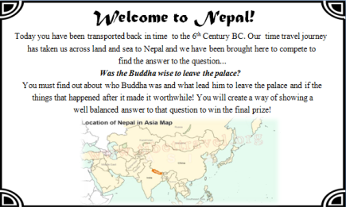
The first thing that happens in the pupils watch the video at https://www.youtube.com/watch?v=DpUaJgx0rWM as an intro and can read the information sheet. They need to know they will work as a group to complete and create a presentation of the answer in their groups (could also be a written task). Could us thinking hats for different members of the group.

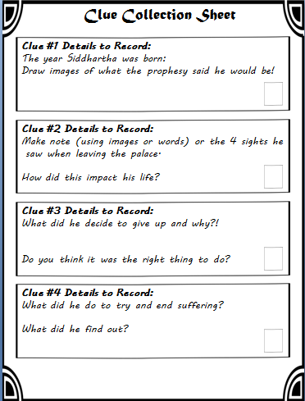
Give the pupils their worksheet and explain they need to make notes as they go round. They need to be aware there might not be instructions for everything but they need to record all they can.
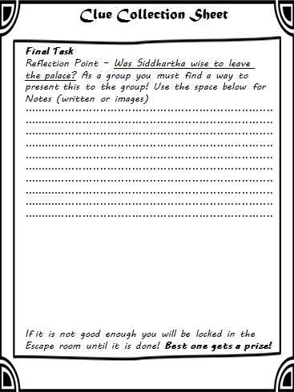

Behaviour Management
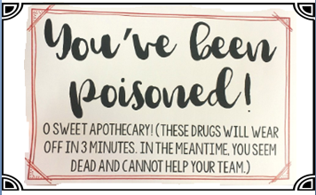
Included in the resources are “Poison Cards” which allows teachers or group leaders to give time outs to those not doing as they should. This keeps in theme but allows control over pupils who cannot get along.

Main Tasks
Five boxes will be set up around the room (https://www.ebay.co.uk/itm/Liberty-Trinket-Book-Boxes-Jewellery-Box-Storage-Book-Shape/142906772638?ssPageName=STRK%3AMEBIDX%3AIT&_trksid=p2057872.m2749.l2649 ), each has a combination padlock on them. (https://www.ebay.co.uk/itm/Job-lot-of-combination-padlocks/173422323868?ssPageName=STRK%3AMEBIDX%3AIT&_trksid=p2057872.m2749.l2649 ) Each has a clue card riddle that tells the pupils what to do to get the lock code (3 digits). The pupils can either be sent to different stations or choose at random.
Clue station #1
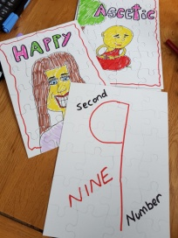
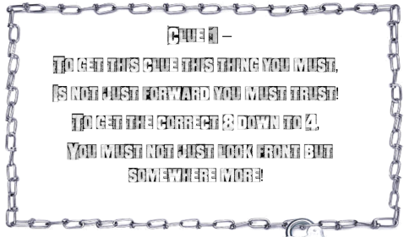
This is a station with eight puzzles that I made (https://www.ebay.co.uk/itm/A5-Blank-Jigsaw-Create-Your-Own-Jigsaw-Puzzle-DIY-Craft-Pack-of-16-Teach-Me/371724474858?ssPageName=STRK%3AMEBIDX%3AIT&_trksid=p2057872.m2749.l2649) . The pupils must put together to see which has one of the 4 sights of the Buddha on. On each puzzle (on the back) is one of the numbers and which order it goes in. Pupils must work out which are the correct 4 puzzles and then work out the code is on the back of them. This gives them the details of the first part of Buddha’s life. Note that they actually need to have done clue station #2 to get the 4 sights! This just adds to the fun.

Clue Station #2
This has a few things needed. Firstly the pupils get a blow up globe (https://www.amazon.co.uk/gp/product/B078WQ39NW/ref=oh_aui_detailpage_o02_s00?ie=UTF8&psc=1) and I put the code to a Mexican wheel cipher next to Nepal on the map. There is a note about how to use this that also sits on the table next to the clue instruction. You need the wheel template in the resources too (from activehistory.co.uk/escape_room ).
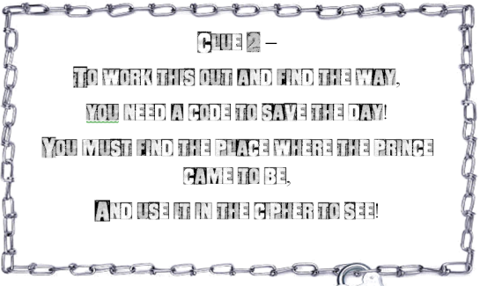
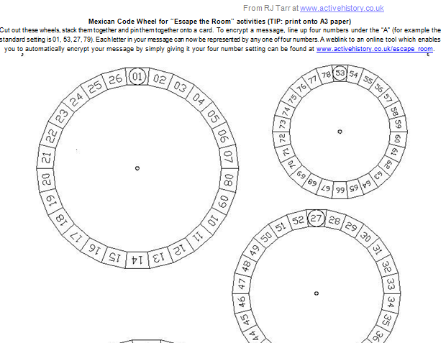

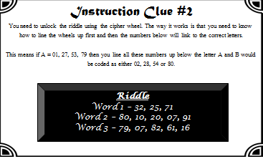

Clue Station #3
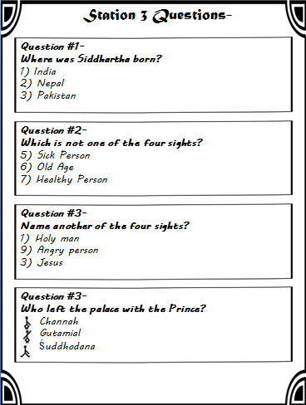
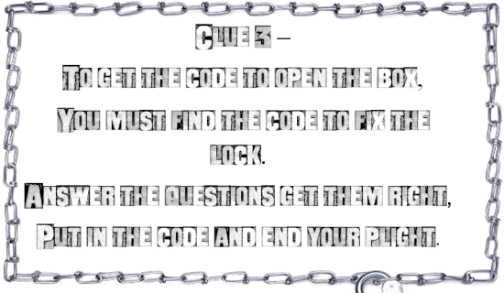
This is a simple multiple choice about some of the information from the boxes. Each of the answers gives them a number to answer the code.

Clue Station #4
This has two parts – Firstly the pupils have an image and must find the instruction words hidden in it that tell them what to do. In mine it says to ask Mrs George with the code word Buddha. After this I give them a light and between the lines of the clue the numbers are written in UV pen. (https://www.ebay.co.uk/itm/Permanent-Ultra-Violet-Security-Marker-Pen-Invisible-Warning-Stickers-UV-Light/163116410865?ssPageName=STRK%3AMEBIDX%3AIT&var=462275506412&_trksid=p2057872.m2749.l2649 )
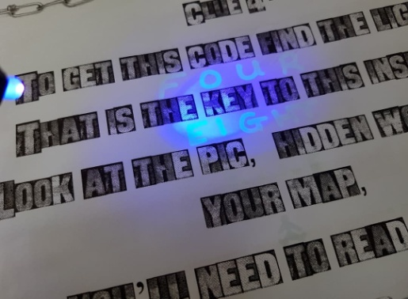
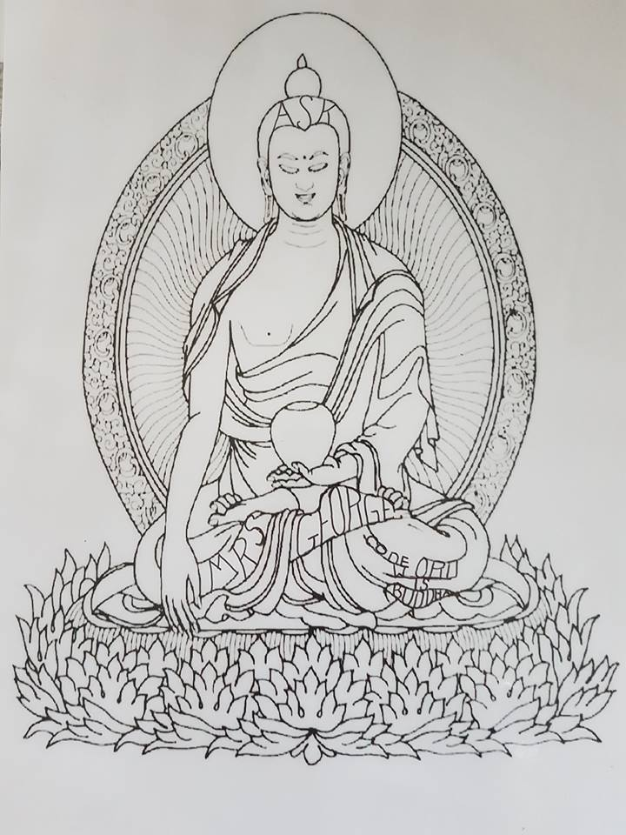

Clue station #5
The clues for this have actually been involved in other clues and the pupils were expected to see and take note. There were 3 symbols in the clues and those symbols are now on the final clue card. One was on the back of the puzzle, one for the last multiple choice question and one in the UV pen. They can’t open this until all other ones complete. This is because the box contains a QR code to scan for a video from the BBC that recaps the whole story. (https://www.bbc.co.uk/programmes/p010xtz3) . This allows a good recap if anything missed and SEN to access using a different way that is not just reading.
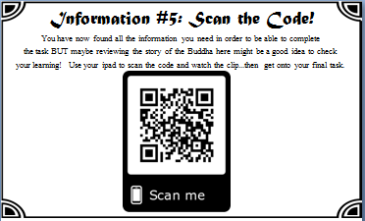
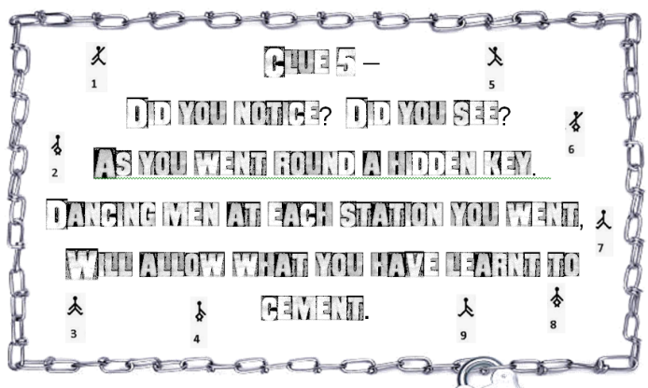

In the boxes
Inside each box is part of the story of the Buddha and once complete they will have the whole story and be able to complete the question answer.
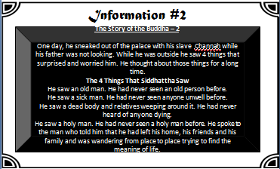
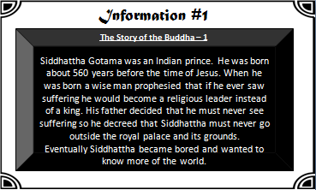

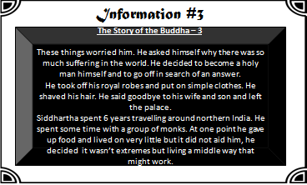
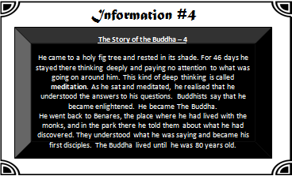

Task
The aim is now for the groups to consolidate their learning and present their findings. This is where you should share the success criteria. I have not added levels as then different schools can use depending on how they level.
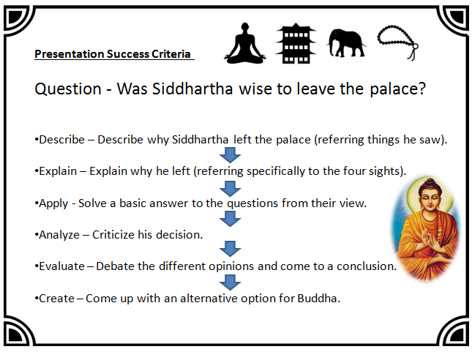

Plenary
Many ideas could be used here –
- Q&A
- Post-it exit card with short twitter length answer to question (fits nicely with escape idea)
- Quizlet live
- Kahoot

I hope this is helpful! This could easily be adapted to other things and I will be making one on Jesus in the future. It does take time to refine (but this resource will take a lot of the time planning out) and some things do need to be brought!

