<Your Company>
Pupil wellbeing proposal

Overview
In recent years pupil’s wellbeing has become for front of main stream news and social media. At a time where pupil seem to be inundated with new ways to communicate research indicated that child happiness is low in some specific areas.

Though schools alone cannot solve this problem alone they are high on the reason for dissatisfaction of pupils. This schools need to take an active role in looking into wellbeing of their pupils and assessing what they can do.
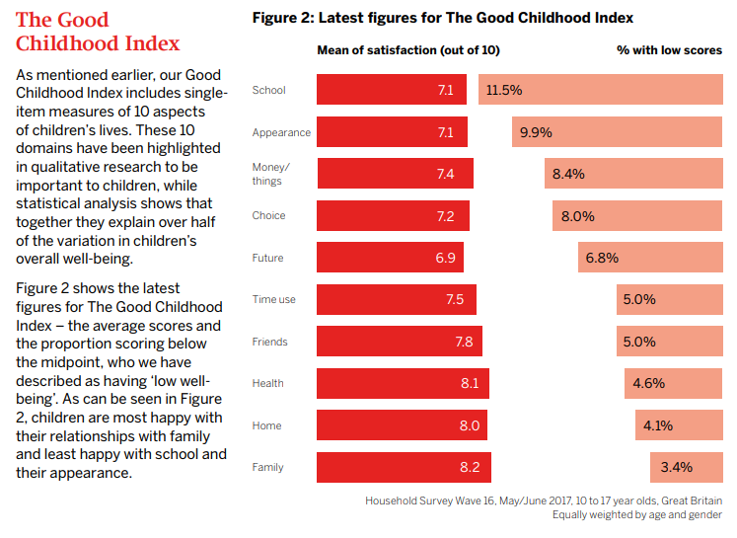
The table above shows the areas where children show ‘low well-being’ from The Good Childhood Index completed in May/June 2017. This indicated that school and appearance are areas where well-being is seen as low and should be a focus for any educational institution to identify and solve.

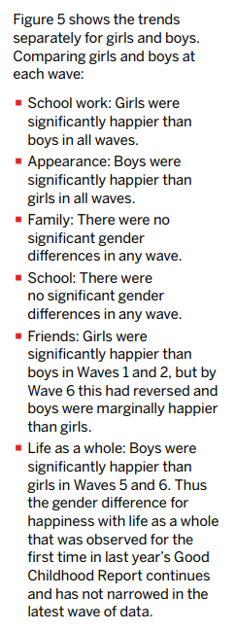
The Objective
This report allows the ability for schools to look at different areas of pupil well-being and pick activities that will impact different areas linked with low well-being and happiness. Different research will be referred to give a clear understanding of items and ideas that have proven to give a positive impact rather than quick fixes.

The Solutions
Solutions may not all encompassing and may not work in all context. It may be that an investigation may need to pressed ideas quoted here to assess which areas are weakness within you school. Two examples have been placed at the end of the proposal for use with pupils to guide change.

There is also some research into difference in genders and individuals, so this will need consideration with the context that you work in/run (see figure 5, extract from The Good Childhood Index)

The Proposal
The proposal has been split into three sections, ones that instigate a culture of play, one to focus on giving to others and one looking to increase knowledge. It should be clear that no one section trumps the other and the approach should be taken holistically.

Play and Well-being

It is well documented that pupils are no longer focusing on playing as they move their way through the year groups. Social media and electronics take over and exam stress builds up. This means time needs to be made for items that can combat this and spaces made available for such activities.

Idea Title | Details | Costs
Well-being Space | Designated room, area for pupils to come in times where support not structured like a classroom. This could be manned by older pupils and include board games, mindfulness sessions, chilled music stations etc. It is a place where pupils who feel overwhelmed could come. | Depends if it is designated space or classroom. Could be quite low cost. Donations of games etc.
Well-being ambassador | Pupils become well-being ambassadors on school councils and report back on what they would like to see changed. These are linked to the surveys as well or as a starting point. They are to monitor provisions and research other ideas to take the pressure off staff well-being. | Nothing
Well-being Working Wall | Well-being ambassadors get a space to promote ideas of events to do with well-being. Can include shout out to pupils that have done well around the school. | Low- Cost of a display and paper.
Homework free night for all years | Pupils in all years are awarded a homework free night and are asked instead to read. This adds a focus on to DEAR, still gives them something to achieve in Prep. Club but means nothing is to be handed in and gives some release to both staff and pupils. | None
Rethink of homework. To include experiences (experience passport that focuses on play) | Added activity passport for pupils and parents as a challenge with rewards for completing to engage in moving pupils off computers and social media and get them outside, talking and playing at home as well as in school. | None
Redesign playground | With a focus on playing together. A focus on sharing and fairness.  - Benches that face each other to promote discussions.  - Sensory area.  - Quite zone.  - Challenge area where pupils aim to push themselves further each break/lunch. | Could be very costly but an investment for the future. Or look to local business/parents skills to help.
Lego/Play therapy | Focus on the use of play to support pupils within the school. Lego therapy can be an excellent way of getting this done and putting focus on different ways of supporting pupils. https://www.welovebricks.com/lego-therapy/ | Training is around £220 and then need to get Lego. Donations would be a good way of saving costs here.
Therapy/Reading Pet | Introduction of pet therapy or reading. It should be noted that a school should think carefully about how this is done. A lot of training needs to be in place to ensure effective safe use of the dog so that all benefit. It should not be at a whim or just a dog brought in for use in school. | None. If staff pet already then cost incurred by that member.
Mindful Culture | Pupils need to know they are safe to be mindful and self aware. This may mean a complete change in culture. It might mean, at first, you need to make these mindful times obvious. It could be that at a certain time of the day you practice mindfulness activities until the pupils (and staff) are confident on how to complete there. Some books are available for guided mindfulness such as-  - https://www.amazon.co.uk/Mindful-Kids-Mindfulness-Activities-Monkeys/dp/1782853278/ref=sr_1_1?keywords=mindful+children&qid=1557153412&s=gateway&sr=8-1  - https://www.amazon.co.uk/Mindful-Games-Activity-Cards-Mindfulness/dp/1611804094/ref=sr_1_8?keywords=mindful+children&qid=1557153412&s=gateway&sr=8-8  Also think about having a stop bell mind morning or day. This is a time pupil’s just need to stop.  Also other things can help where pupils do things purposefully, like walking purposefully. This means at a slow pace where they look around and not down at the floor. Teach them to focus on things and people around them.  A culture shift for all is needed if this is successful and staff will need to be committed too. | None
Phone rest bite system | This allows parents and pupils to hand over electronic devices as a rest bite system for a few days/evening or over a weekend. It might be something the whole family decides to do!  This encourages all to have time away from screens with the support of the school and without temptation.  Social media is an increasing problem linked to anxiety and this allows pupils to take control and have time away.  As the quote below shows, time away from a phone can be scary but if supported would be very useful to many who have become addicted.  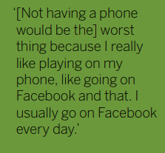 | Cost of secure boxes. £50  Will need a disclaimer statement about responsibility for accidents or stolen phones or to consult insurance company about keeping on site.

Giving and Well-being/Support

Social psychologist Elizabeth Dunn has found that happiness is found in giving (https://www.ted.com/talks/elizabeth_dunn_helping_others_makes_us_happier_but_it_matters_how_we_do_it?language=en) but only when the effects of that giving can be personally experienced. Thus I propose that schools not only make giving a high priority but that that is not enough on its own. Pupils must see the impact of this kind of spending to be affected fully and gain the happiness and well-being that is associated with it.

Idea Title | Details | Costs
Opportunity to see the effects of charitable donations | Pupil actually see the effects of their donations to any given charity by meeting people or seeing videos of those directly affected. | None
Create community charity events. | Pupils are actively involved in giving something that is not just money. They put on bake sales for local issues, they create a food bank in school where locals can come and access food. Extreme ideas might be things like sponsoring a refugee family http://www.sponsorrefugees.org/what_it_is | From nothing (volunteer time) to as much as people are willing to give/put in.
Visit Local schools | Pupils give time. They go and see different types of school and share culture and aid in things like reading for younger children. | None
Visit other classes/ages in school | This allows a community to develop where everyone is committed to each other. This could be integrated into praise and behavior systems.  Feeling part of a community can improve well being and pupils could choose other classes to go to share rewards (lovely if a child as a sibling in another class!) or they could go and get advice from older classes if they have been in trouble from pupils nearer their age. This level of support is essential for wellbeing and support from peer members. (See The Good Childhood Index on social media in the “Update PSHEE scheme section) | None

Education of well-being
Idea Title | Details | Costs
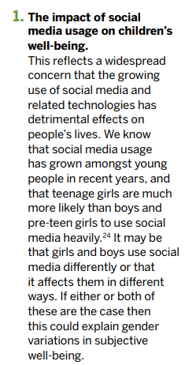  Updated PSHEE scheme | PSHEE needs to be a discrete subject to be most effective and should cover aspects of mindfulness and well-being.  In this schools should address aspects such as social media usage, appearance issues, mental health and bullying. As shown, these are the areas that The Good Childhood Index has highlighted as main areas that go against child happiness. | None
Buddy Systems | Many buddy systems exist where pupils are trained up to become support for other pupils.  Such are –  - https://www.worthit.org.uk/solutions/wellbeing-ambassadors-workshop/  - https://diana-award.org.uk/mentoring/i-want-mentoring-in-my-school/  - https://hub4leaders.co.uk/learning-hub/resources/pupil-wellbeing-ambassador-programme/pupil-wellbeing-ambassador-programme/  - https://www.girlsonboard.co.uk/ | Depends on training scheme used. Can be around £200
Parent Sessions | Sessions are offered termly to parents to train them about different mental health, mindfulness and other sessions as needed to support them as parents. This could be completed by trained staff member or outside speakers.  Issues sometimes arise when these are poorly attended so could be added on at the end of the school day when some parents are around anyway as well as evening sessions. | None

Specific Support
For some pupils they will need more specific support for individual causes. In this section this gives some areas where things can be put into place for some of these situations as proactive rather than reactive. These will depend on the school and age of the pupils.
Idea Title | Details | Costs
Sibling Club | Often, when focusing on pupils with things like home issues or SEND their siblings can be the ‘forgotten victim’. For this reason it would be useful to focus on those who have siblings with needs/issues as a support group. This can aid their well-being as well as parent as it takes the pressure off them. | None
School Councilor | Due to budget cuts there are fewer and fewer in schools but a valuable asset for all. Referring pupils to a trained member reduces pressure for the student and the teachers. If budget is an issue cost can be transferred to parents (though this may still be an issue) or split across different cohort schools. | Cost to parents – often around £30 a session
Buddy Bench | Within the playground redesign a buddy bench could be introduced to support those who are alone at break or lunch. Anyone who is lonely or without friends sits on the beach and people in the playground come and ask them to play. There can work with well-being ambassadors in the playground to make sure no one is left alone. 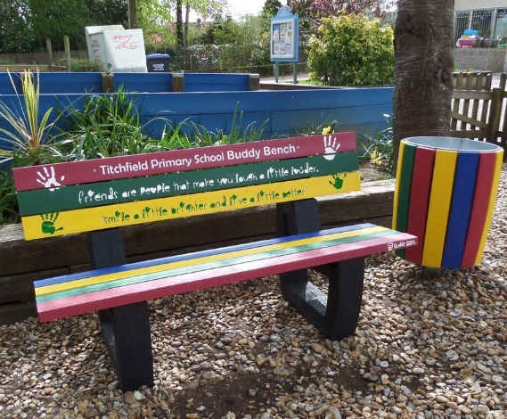 | Cost of bench and paint - £100
Break away rooms | This is an area for those finding the day hard and may need some time out. This is not a punishment but an area of support and would need to be used with parents and pupil knowledge of expectation of how it is for small amounts of time throughout the day, not for long sessions to avoid other aspects of school. | None
Specific Well-being lead teacher | To keep up to date with research and strategies in regards to well-being. They are to keep track of provisions and culture within school and drive CPD and assessment of how items have worked. They should be given sufficient time to monitor and reach via PPA. This should not be an added role to management already in place unless more time is given. They can update staff via meetings. | Depends if paid role. If not time of timetable could be offered.

The aim is the proposal is low cost and effective. It may not be that all items can be integrated all at once but that the best, most accessible ideas can and others can be added as time and budget allows.
Thank you for your consideration,
<Your name>
<Job Title/Role>

